Meaning and Definition
CSG Field Service Management provides field service management and automation tools that optimize technicians’ productivity and respect to customers’ availability. This fully integrated workforce solution turns every aspect of field delivery, installation and service operations into a competitive advantage. It is the engine that processes more than 100 million work orders every year for some of the world’s largest communications service providers. CSG Field Service Management works in concert with any billing and order management system, and its robust set of APIs keeps information flowing from your back office into CSG Field Service Management and back again, ensuring that all data is current and updated based on changing conditions.
Characteristics
- REAL-TIME TRAFFIC- This functionality triggers alerts based on traffic events in the area, allowing technicians to determine an alternative path, or the ability to re-assign the technician to another job that reduces drive time.
- OPTIMIZED SCHEDULING- Automated job assignment tools incorporate patented routing algorithms to enable service providers to achieve over 98 percent on-time arrivals,within 1- to 2-hour appointment windows. Reduce dispatcher calls by 50 percent so they can focus on solving higher-priority issues
- A 360-degree view of all field activities in a single dashboard

WFX Applications
- ProdOps -Production Operations
- GUI - Graphical User Interface
- USSCCS - Upstream Server
- DSSCCS - Downstream Server
- TechNet - PocketNet Phones
- Reports - Reporting Tool

Monitoring tools used by FSM Team

Solarwinds

Zabbix

Kibana

Stathub is using for Monitoring FSM API calls

WFX Architecture

Basic architecture of FSM is a typical client server architecture as below

Client ↔ BigIP ↔ API gateway server ↔ Backend servers ↔ Databases

Front end client- The client can be either web-based client or a desktop-based client. The web-based uses ext.js based framework, The desktop-based clients are called vcmc program. It can include several modules, like technician management, workforce management etc.

Big IP - BigIP provides the traffic management between the client and the backend server. You can view it like software version. Besides the security and load balance, it did the reverse proxy to the servers behind. The static information, and Post/Put/Delete request can be processed differently.

API gateway server- It plays the role as the API gateway, receives the HTTP Get/Post/Put/Delete request from the front end client and proxy the requests to the backend server.

Backend servers

There are several backend servers work together

Route Server: Receives requests from the WFM GUI for the purpose of assigning work orders to technicians.

Digital Broadcast System Server: Responsible for forwarding completed work orders to the digital service provider’s inventory system.

Drill Down Server: Responsible for providing map images and geographical data to the map server. (Real time traffic)

Dispatch Utility Server: Responsible for calculation of quota for the WFM GUI.

Downstream Server: Responsible for interfacing with external billing system.

Map Server: Responsible for providing map images, latitudes, longitudes, and driving directions to the WFM GUI.

Technician Alert Server: Responsible for forwarding alerts, outages, and messages to technicians and cleanup thereof.

CE Device Server: Communication server used between dispatch and technicians to administer work orders in the field for technicians using Windows CE devices.

Browser Device Server: Communication server used between dispatch and technicians to administer work orders in the field for technicians using HTTP based devices.

Upstream Server: Responsible for interfacing and forwarding outgoing work order updates to the external billing system.

Workforce Server: A middle tier server between WFM applications and the WFM database

Apache Server: Transacts with the web-based applications.

Work Order Update Push Server: Responsible for pushing work order updates to the WFM GUI clients based on the clients registering interest via the filter window selections.

Database

There are two databases.

ENT database contains the organization, personal, auth/token, session and other support information, basically non-business login data.

WFX database contains the business data. It also includes the difference instances for R/D and QA.

Work Order Flow of FSM

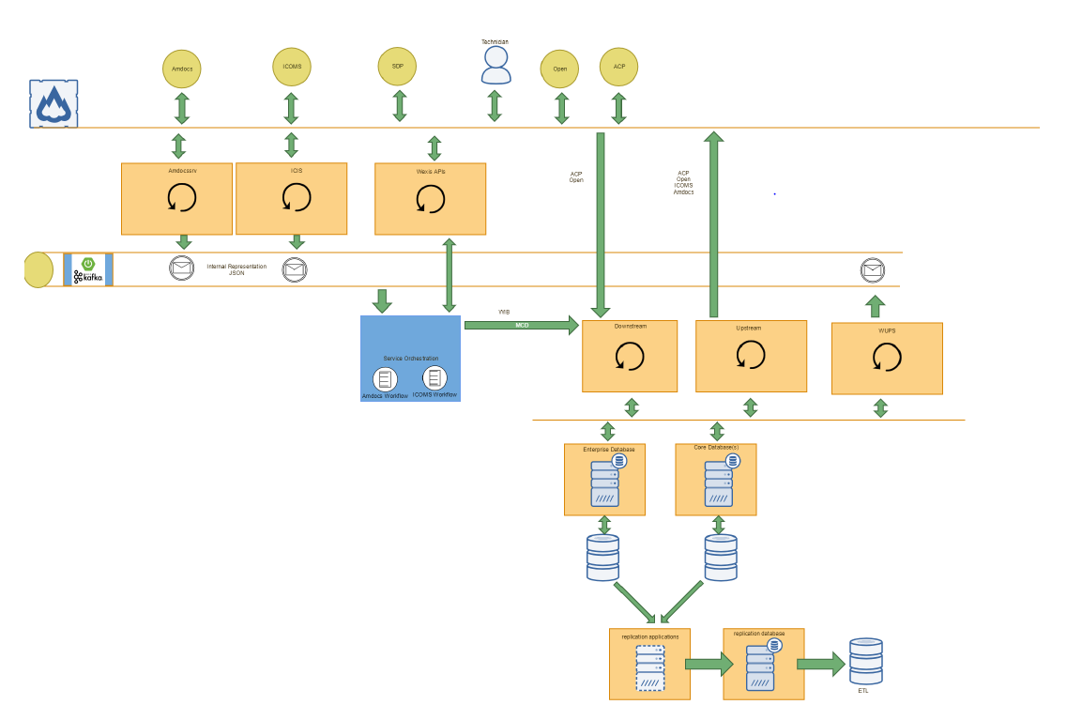

Top 12 FSM APIs (October-2019)
Transaction | Rank
GetWorkOrder | 2
SetGPSDeviceEvents | 3
GetTechStatusByTech | 4
GetTechJob | 5
SetTechGPS | 6
GetTechShiftEventsByTech | 7
GetWorkOrderByAccount | 8
GetTechInventory | 9
PostWorkOrderJob | 10
SetTechStatus | 11
GetTechProfile | 12
UpdateOMS | 13

Get transactions (Get- select)
1) Client calls WFXAPI REST API
2) WFX broadcasts that API to each OLTP Oracle database to find the workorder in the request
3) With the work order number, the application layer accesses the database.
4) A select query returns the data.
5) WFXAPI response to client

Post transactions (Post – update)
Post transactions will take a little longer because they have the following workflow:
1) Client calls WFXAPI REST API
2) WFX broadcasts that API to each OLTP Oracle database to find the workorder in the request
3) With the work order number, the application layer accesses the database.
4) An update query runs.
5) WFXAPI calls SLBOS
6) SLBOS updates ACP
7) ACP responds to SLBOS
8) SLBOS responds to WFXAPI
9) WFXAPI response to client

We need to ensure following details provided in tickets before assigning to FSM bin
- Summary of the Problem (Steps to reproduce):
- Impact:
- What we have Researched:
- Next Steps: (Bullet points for team to continue investigation)
- We can provide all the relevant Logs with snapshots indicating the time frame as well

